CEBU INSTITUTE OF TECHNOLOGY
UNIVERSITY

COLLEGE OF COMPUTER STUDIES

Software Requirements Specifications
for
LOOP - Learning Object Organizer Plus

Signature

Aton, Marc Venry - Team Lead, Back-end Developer _____________
Langga, Edwin - Systems Analyst, Back-end Developer _____________
Roxas, Jessie - Front-end Developer, Quality Assurance Engineer _____________
Quilaton, Krizette Gen n - Front-end Developer, Documentation Officer _____________

Change History
Name | Date | Reasons for Change | Version
LOOP  [Software Project] | 06/23/14 | This is the continuation of the Learning Object Organizer Plus (LOOP) which was our Software Engineering project. | R1.0
 |  | The documentation must be updated and finalized before it is to be submitted. | R2.0

Preface

This is the Software Requirements Specification (SRS) for LOOP otherwise known as Learning Object Organizer Plus.

This software is intended for Developers and Reviewers, specifically the Developers and Reviewers actively contributing and participating in the E-Learning Center of CIT-University. It is assumed that the Developers and the Reviewers have sufficient knowledge in web applications, programming and the “Learning Objects” concept.

Others involved in testing, maintenance and review of the system should also be aware of the information reflected in this document.

Table of Contents

Signature 2
Change History 3
Preface 4
Table of Contents 5
List of Figures 6
1. Introduction 7
1.1. Purpose 7
1.2. Scope 7
1.3. Definitions, Acronyms and Abbreviations 7
1.4. References 8
1.5. Overview 8
2. Overall Description 9
2.1. Product perspective 9
2.2. Product functions 9
2.3. User characteristics 10
2.4. Constraints 10
2.4. Assumptions and dependencies 10
3. Specific Requirements 12
3.1. External interface requirements 12
3.1.1. User interfaces 12
3.1.2. Hardware interfaces 12
3.1.3. Software interfaces 12
3.1.4. Communications interfaces 12
3.2. Functional requirements 13
3.2.1. Main Use Cases 13
3.2.2. Developer Use Cases 14
3.2.3. Reviewer Use Cases 16
3.2.4. Admin Use Case 17
3.2.5. Login Admin 17
3.2.6. Monitor Accounts 18
3.2.7. Account Actions 19
3.2.8. Add New Account Requests 19
3.2.9. Search Account 19
3.2.10. Change Password 20
3.2.11. Block User 20
3.2.12. Delete Learning Objects 20
3.2.13. Review Learning Objects 21
3.3. Performance Requirements 21
3.4. Design constraints 21
3.5. Software system attributes 21
3.6. Other requirements 21
4. Appendixes 23
5. Index 25

List of Figures

Figure 0 – History Page for Developer View 12
Figure 1 – History Page for Reviewer View 12
Figure 2 –History Page for Admin View 13
Figure 3 – Assigning Reviewer 13
Figure 4 – Upload of Learning Elements 14
Figure 5 – Developer Use Case 14
Figure 6 – Reviewer Use Case 13
Figure 7 – Developer Login Use Case 14
Figure 8 – Search all Learning Objects Use Case 14
Figure 9 – Upload Learning Objects Use Case 14
Figure 10 – View all Learning Objects Use Case 15
Figure 11 – Delete Learning Objects Use Case 15
Figure 12– Account Settings 15
Figure 13 – Reviewer Login Use Case 16
Figure 14 – Review Learning Objects Use Case 16
Figure 15 – View Learning Objects for Review Use Case 16
Figure 16 – Search Learning Objects for Review Use Case 17
Figure 17 – Admin Use Case 17
Figure 18 – Login Admin 18
Figure 19 – Monitor Accounts 18
Figure 20 – Account Actions 19
Figure 21 – Add New Account Requests 19
Figure 22 – Search Account 19
Figure 23 – Change Password 20
Figure 24 – Block User 20
Figure 25 – Delete Learning Objects 20
Figure 26 – Download and Review Learning Objects 21
Figure 27 – Appendix 1 23
Figure 28 – Appendix 2 23
Figure 29 – Appendix 3 23
Figure 30– Appendix 4 24

Introduction

Purpose
The purpose of this document is to specify the system’s functions, scope, limitations, dependencies and other information that could help set the bounds for the development of the system. This document will serve as a checklist in determining the project’s level of completion.

Scope
The system supports the browsing and uploading of learning objects. There are two different types of user account; they are the developer and reviewer accounts. There is also a super user account which is the admin account. When you are logged in as a developer, you have access to all your learning objects in all the phases of their development. You will be able to search and view all your “Newly Uploaded, Reviewed, For Review and Ready to Use” learning objects as well as upload new learning objects and update them from time to time. When you are logged in as a reviewer, you can view and search for all the learning objects uploaded by the developers except the learning objects that have a rating of four (4) or five (5) because these will be passed on to the admin. Before a reviewer can review or rate a learning object, he/she must first download the learning object. A reviewer can only give a rating of one (1) to four (4) for a specific learning object because only the admin can give a rating of five (5) for a learning object. We have a special download function for reviewers and the admin.
Only the admin has the right to decide whether or not the particular learning object is “Ready to Use” or still needs revisions. The scope of users, for now, would be the faculty and staff of CIT-University. This means that the system would be deployed on the CIT-U eLearning server and is consequently only visible within the campus network.
Students are out of our scope. Our system is geared towards the faculty and teaching staff because they will be uploading learning objects and reviewing them, they are the main users of our system. The system will be responsible for filtering out the different stages of the learning objects and categorizing them into ready to use, reviewed/for review and newly uploaded/for review.

Definitions, Acronyms and Abbreviations
Learning Object – an interactive presentation of a certain subject/topic designed to help in academic development.
Learning Element – a generic type of learning material which will be reviewed and rated the same as LO.
LO – abbreviation for Learning Object.
LE – abbreviation for Learning Element.
Admin – short version for Administrator
Organizer – a thing used for organizing. Equipment that helps you arrange information.
LOOP – Learning Object Organizer Plus
Cloud Framework – a concept of online computing aimed at making system resources available to a large number of users by storing them on a common network (typically the internet) as shared resources. Users download only the necessary or requested resources and can use these on their respective devices anytime regardless of network connectivity.
eLearning – learning with the aid of computers.

Review vs. View – To review is to check and rate a learning object and certify if it is ready to use, or if it needs to be revised and then reviewed again. To view is to simply download a learning object from the main-view list and view it on your device.
CCS – College of Computer Studies
LOIDE – Learning Object Integrated Development Environment
LOB – Learning Object Builder

References
Cloud Computing - http://en.wikipedia.org/wiki/Cloud_computing
The Learning Objects – CIT-U local server: 172.31.11.208
Head First HTML and CSS 2nd Edition 2013; Author: Elisabeth Robson & Eric Freeman
PHP Application Development with NetBeans Beginners Guide 2012; Author: M A Hossain Tonu
PHP6 and MySQL 6 Bible; Authors: Steve Suehring, Tim Converse, Joyce Park
JavaScript: The Definitive Guide 5th Edition; Author: David Flanagan
Learning jQuery: Better Interation Design and Web Development; Authors: Jonathan Chaffer, Karl Swedberg
http://www.w3schools.com/html/html5_intro.asp
http://www.w3schools.com/css/css3_intro.asp
http://getbootstrap.com/components/
http://getbootstrap.com/javascript/
http://net.tutsplus.com/category/tutorials/
http://www.developphp.com/
http://ellislab.com/codeigniter

Overview
The next pages of this document will show information describing the system’s specific functions, constraints, dependencies and interfaces. The contents are divided into two (2) major sections. Section 2 will contain the general specifications while Section 3 will show more details on the technical side of the system.

Overall Description

Product perspective
Learning Object Organizer Plus or LOOP only covers the reviewing and uploading of the learning objects with the exception of the download feature which is only available for reviewers and admin. Features like uploading and reviewing of learning objects are the main features done by this system. The systems that should essentially communicate with LOOP are Informatron CMS and LOB. Informatron CMS gets the ready to use learning objects from our system and it will be able to distribute the learning objects to the students. LOB is responsible for the packaging and zipping of the learning objects. Hence, this is an open system. Learning objects that are ready to use or ready for download are taken from our system and are the only learning objects viewable by the students on Informatron. Our filtering system only releases the learning object once it has received a five (5) in our rating system, this means that it has been reviewed by a valid reviewer, and it has been approved by the admin.

Product functions
Developer Functions
- Log in for Developer
- Change account info (email or password)
- Search by name (Normal Search found on upper right of the learning objects table)
- Search Learning Objects or Learning Elements by name, subject, or date added (Advanced Search)
- Upload Learning Objects or Learning Elements.
- Upload Revision/Update Learning Objects or Learning Elements
- View List of Newly Uploaded/For Review, Reviewed/For Review and Ready to Use Learning Objects
- Delete Learning Objects or Learning Elements (You can only delete the ones you have uploaded)
- View History of Revised Learning Objects or Learning Elements.

Reviewer Functions
- Log in for Reviewer
- Change account info (email or password)
- Search by name (Search found on upper right of the learning objects table)
- Search Learning Objects or Learning Elements by name, subject, or date added (Advanced Search)
- Review/Rate Learning Objects or Learning Elements (Newly Uploaded/For Review and Reviewed/For Review)
- View List of Newly Uploaded/For Review, Reviewed/For Review (learning objects with ratings of 1-3)
- View/Download Learning Objects or Elements (can download/view learning objects with ratings of 4 and 5)
- View History of Revised Learning Objects or Learning Elements.

Admin Functions
- Login for admin
- Add new accounts (Developer and Reviewer)
- Block/Unblock Account
- Monitor Accounts (Developer, Reviewer, inactive or blocked)
- Search Users/Account
- Change Password
- View Learning Objects or Learning Elements (no restrictions)
- Delete Learning Objects or Learning Elements (no restrictions)
- Review Learning Objects or Learning Elements (no restrictions)
- Download Learning Objects or Learning Elements (no restrictions)
- View History of Revised Learning Objects or Learning Elements.
- Assign Reviewer to the Learning Object.

User characteristics
There will be three types of users for this software - the developers, reviewers and the admin.
The first two are the intended creators and reviewers of the learning objects. They should both be registered to the system to be able to upload, download, delete or review the learning objects.
The admin is a super user and has control over the users (developers and reviewers). The admin has special functions other users do not have and the admin has no restrictions with regards to the learning objects, unlike the developers and the reviewers. The admin can monitor user accounts, search user accounts, delete any learning object (no restrictions), download learning objects (no restrictions), and review learning objects without restrictions. The admin is the only one who can give a rating of five (5) to a learning object. If a rating of five (5) is given to a learning object, that means it has been approved by the admin and is ready to use.
The developers are the only ones who can upload learning objects. They cannot review or download learning objects. They can also delete their learning objects and upload revisions of reviewed learning objects.
The reviewers are able to download learning objects and then review them. They cannot upload learning objects but they are responsible for rating them and making sure they are ready to use.

2.4. Constraints
- Developers cannot download the learning objects.
- Developers cannot review learning objects and they cannot approve them nor send them back for revisions, because these actions will only be available for the reviewers and the admin.
- Developers can only view, search and delete the learning objects they have uploaded themselves and have no right to view, search and delete the learning objects uploaded by other developers.
- Developers can only upload “.zip” file types.
- Reviewers cannot upload new learning objects or learning elements nor delete them.
- Reviewers must download the learning object or learning elements before they can review them.
- Reviewers are only allowed to view and download the learning objects or learning elements with ratings of one (1), two (2) or three (3) only.
- Reviewers are only allowed to give learning objects or learning elements a rating of one (1) to four (4).
- There may be only one admin user.
- Only the admin can add accounts(reviewer/developer)
- Only the admin can give learning objects a rating of five (5).
- An admin must download the learning object before he/she can review them.
- An admin cannot review a learning object or learning elements that has not yet been reviewed by a reviewer.
- Once a learning object or learning elements is published it can still be revised / for review and the whole process will loop.

Assumptions and dependencies

This system relies on the E-learning server since we will be getting the available learning objects from the said server. It is assumed that once passed on to this system, the content is to be categorized into three groups or stages. The categories are Newly Uploaded/For Review, Reviewed/For Review and Ready to Use. In order to categorize the learning objects, we implemented our own rating system that rates the learning objects from one (1) to five (5) where one (1) is a newly uploaded learning object and five (5) is a ready to use learning object.
Our system communicates with Informatron and LOB. LOB will zip or package the learning objects and use LOOP to upload the said learning objects. Informatron distributes the learning objects to the students. Any errors or bugs that may occur in the process may affect Informatron CMS and LOB, which are systems related to this.
The system must also check whether learning objects that are to be uploaded meet the specific requirements such as file types and file extensions. There are also separate systems for user management functions like the CCS website.

Specific Requirements

External interface requirements

3.1.1. User interfaces
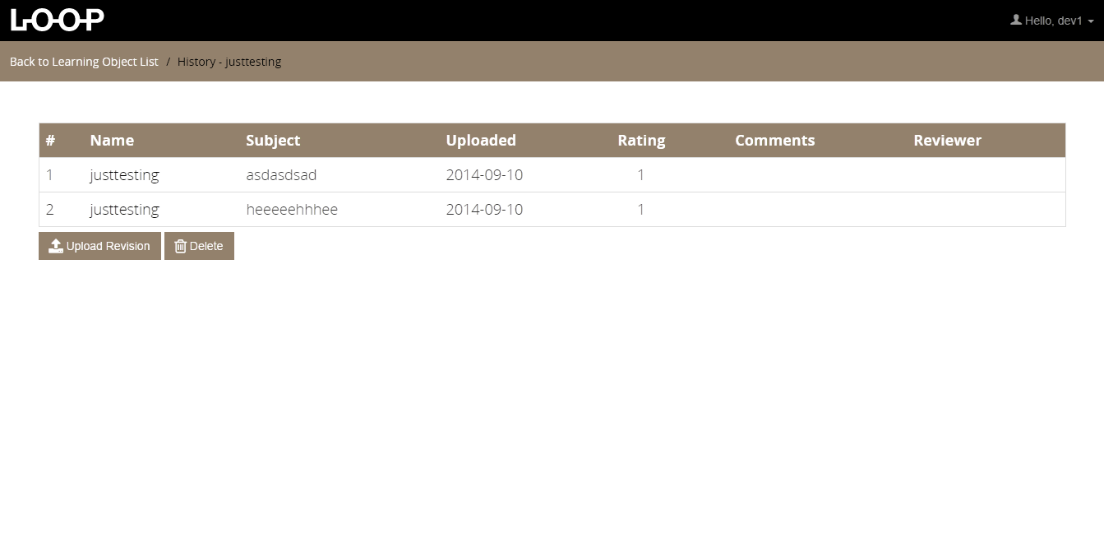
Figure 0 – History Page for Developer
The History Page can be viewed by all developers when the user clicks the Learning Object/ Learning Element.

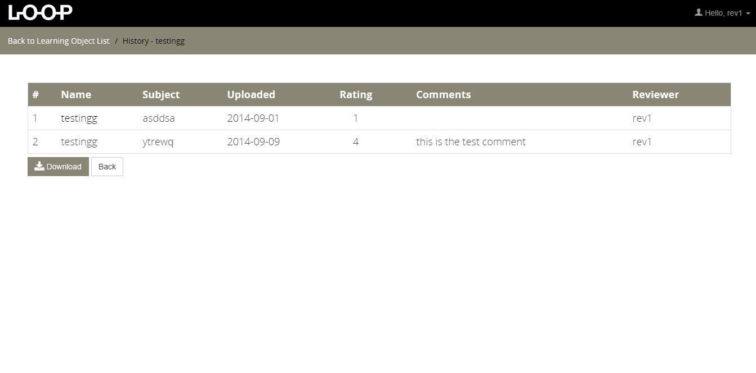
Figure 1 – History Page for Reviewer
The History Page can be viewed by all reviewers when the user clicks the Learning Object/ Learning Element.
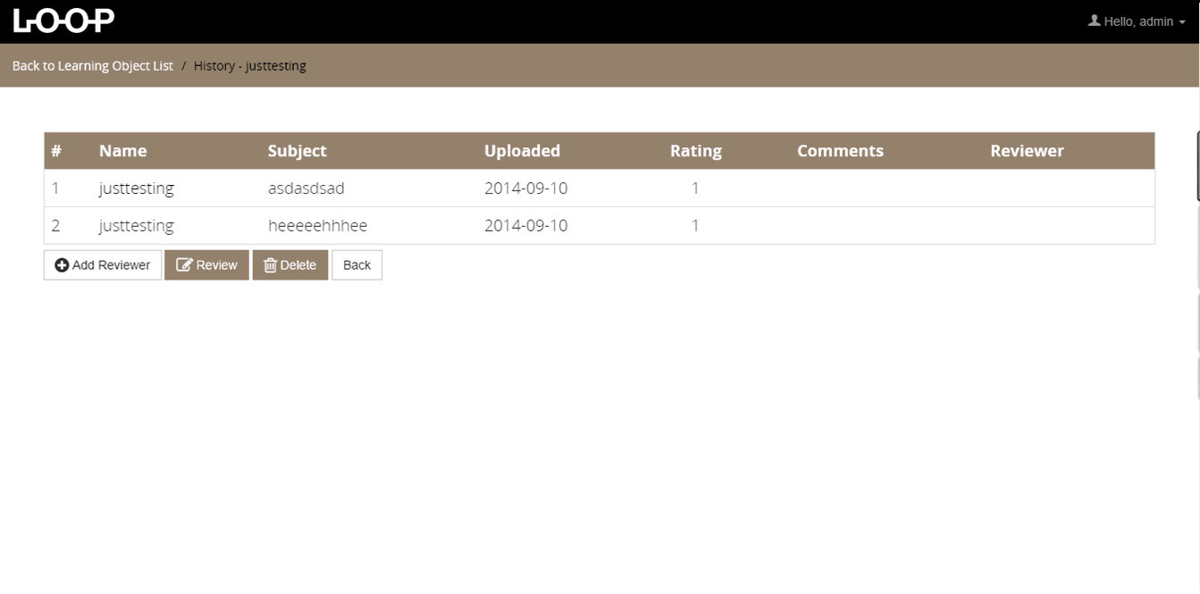
Figure 2 – History Page for Admin
The History Page can be viewed by all Admin when the user clicks the Learning Object/ Learning Element.

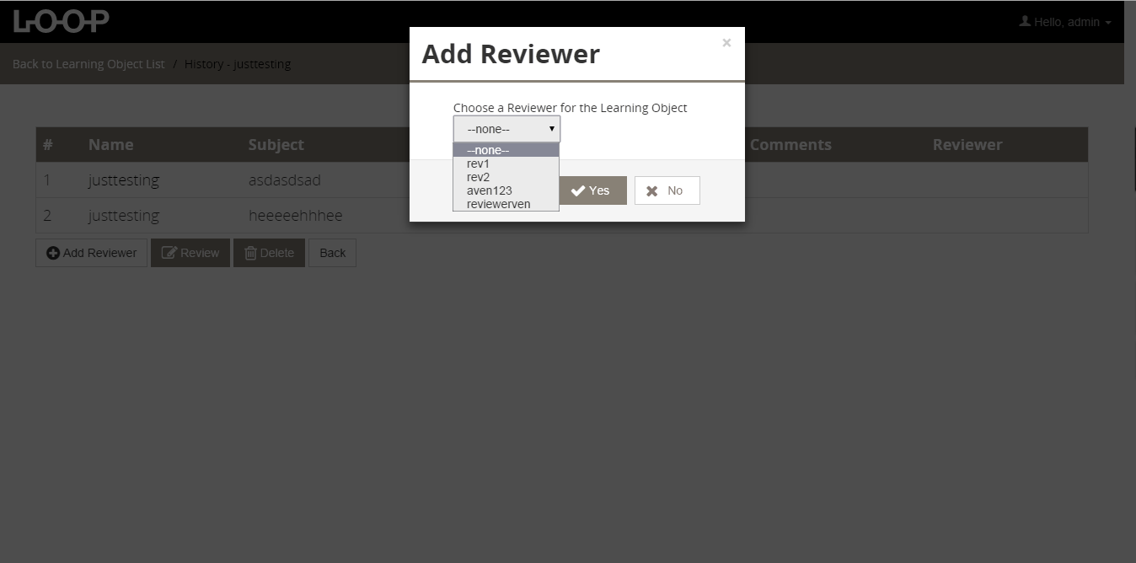

Figure 3 – Assigning of Reviewer
The Add Reviewer Page can be viewed by all Admin when the user clicks the Learning Object/ Learning Element.
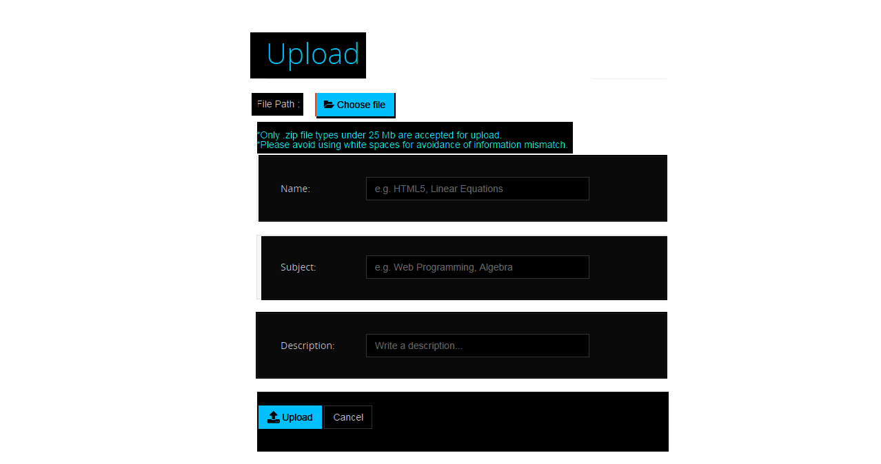

Figure 4 – Upload of Learning Elements / Objects
The Upload Developer Page can be viewed by all Developer when the user clicks the Upload tab.

3.1.2. Hardware interfaces
N/A

3.1.3. Software interfaces
- The system would access the Learning Objects database.
- Apache Web Server
- Net Beans and Sublime Text 2
- Twitter Bootstrap as a front-end framework and responsive design capabilities
- Code Igniter (MVC architecture) as PHP framework
The system will need to access the user management system for login authentication, adding new users, etc. User data will be centralized in the user management system.

3.1.4. Communications interfaces
A network connection with E-Learning’s server is needed as well as a connection with the database where all the information is located. This can either be via LAN (Local Area Network) or Wireless Network.

Functional requirements

Main Use Cases
For Developers
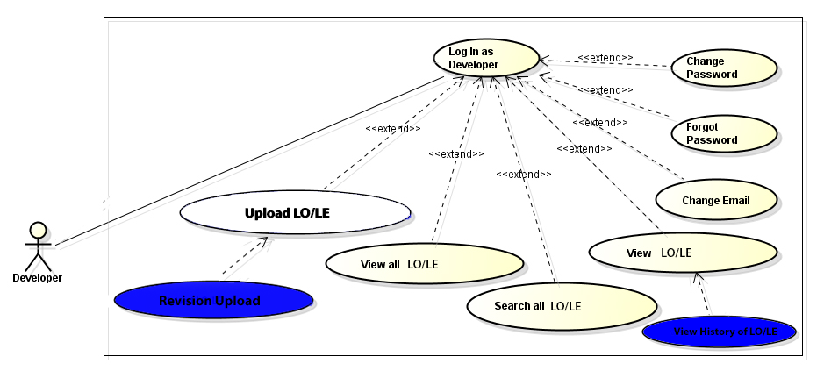
Figure 4 – Developer Use Case
Developers can View all Learning Objects and Learning Elements (Newly Uploaded/For Review, Reviewed/For Review and Ready to Use), Upload Learning Objects, Search all Learning Objects and Delete the Learning Objects he/she has uploaded.
All of these actions require you to login as a Developer.

For Reviewers
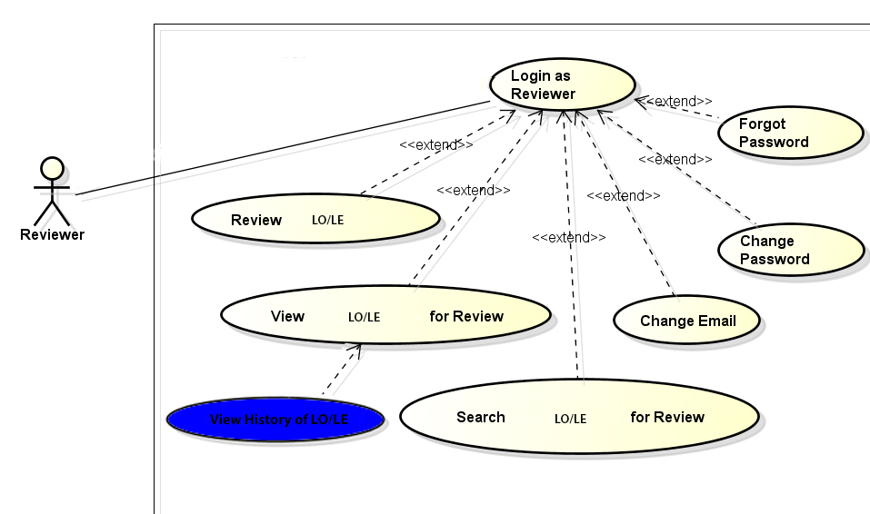
Figure 5– Reviewer Use Case
Reviewers can only View/Download the Reviewed/For Review Learning Objects including Newly Uploaded Learning Objects, Review Learning Objects, Search the Reviewed/For Review Learning Objects.
All of these actions require you to login as a Reviewer.

Developer Use Cases
These are the Developer Use Cases Broken Down Into:
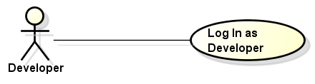

Figure 6– Developer Login Use Case
In order to access the functionalities of a Developer, you need to Login as a Developer. You have to inform the administrator to be a developer in order to use the developer functions.
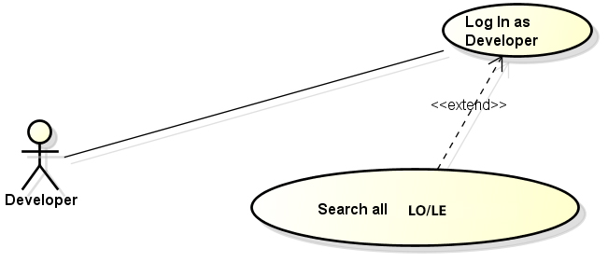

Figure 7 – Search all Learning Objects Use Case
A developer can search all learning objects, while a reviewer can only search the learning objects that are For Review. The Developer can see the Ready to Use/For Review, Reviewed/For Review and Newly Uploaded learning objects that were uploaded by him/her but a developer cannot see other learning objects uploaded by other developers.
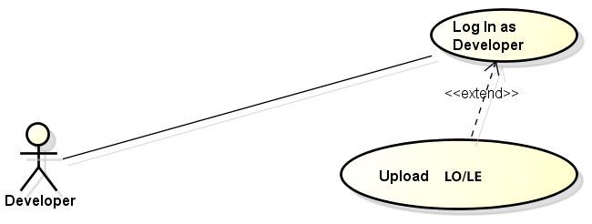
Figure 8 – Upload Learning Objects Use Case
Developers are the only one who can upload learning objects.

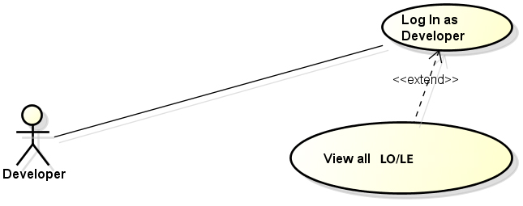

Figure 9 – View all Learning Objects Use Case
A Developer can view all his/her learning objects that are ready to use, reviewed/for review and newly uploaded/for review.
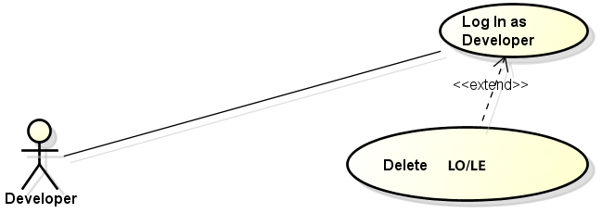
Figure 10 – Delete Learning Objects Use Case

The Developer can only delete the Learning Objects he/she has uploaded. A Developer cannot delete learning objects that were not uploaded by him/her.
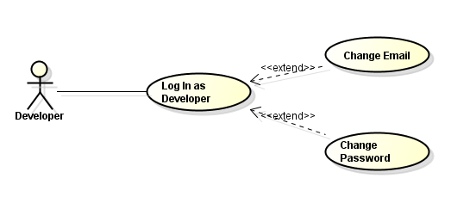

Figure 11 – Account Settings
Developers are able to change their email address and password.

Reviewer Use Cases
These are the Reviewer Use Cases Broken Down Into:
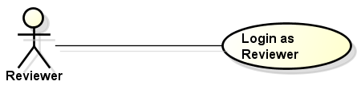

Figure 12 – Reviewer Login Use Case
In order to access the functionalities of a Reviewer, you need to Login as a Reviewer. You have to inform the administrator to be a reviewer in order to use the reviewer functions.
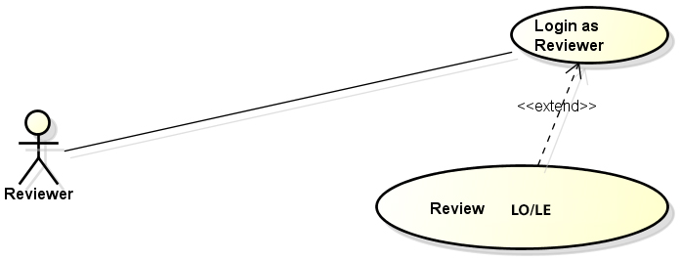
Figure 13 – Review Learning Objects Use Case
As a reviewer, you can review learning objects. You can download the learning objects that are reviewed/for review and newly uploaded learning objects, and then you must give comments and rate the learning objects you have downloaded. A valid rating would be one (1), two (2), three (3) and four (4). A rating of five (5) can only be given by the admin.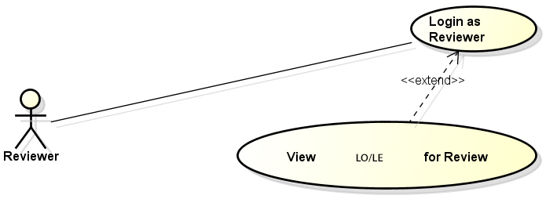

Figure 14 – View Learning Objects for Review Use Case
As a Reviewer, you are the only one who can download learning objects that are newly uploaded, and reviewed/for review so that you may be able to review it. You have no access to the ready to use learning objects and the learning objects that have been reviewed by you or any other reviewer unless a developer uploads a revision of that particular learning object.
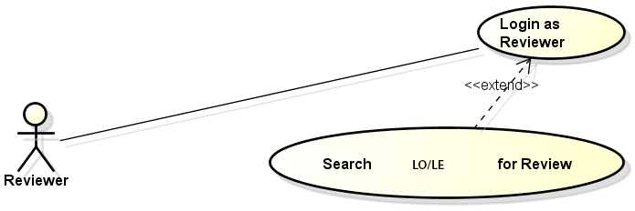
Figure 15 – Search Learning Objects for Review Use Case
A Reviewer can only search the learning objects that are newly uploaded, and reviewed/for review. Since he/she can only access the newly uploaded, and reviewed/for review learning objects, it makes sense that he/she can only search these learning objects.

3.2.4. Admin Use Case
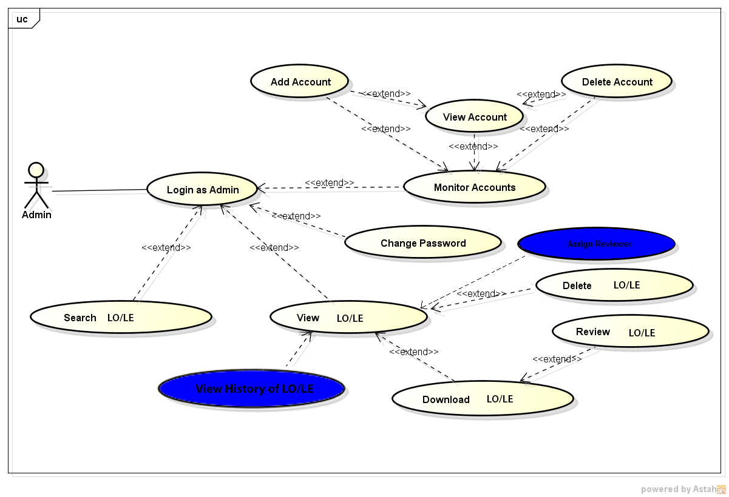
Figure 16 – Admin Use Case
The admin should have a special account that when recognized by the system, redirects to the admin pages. These are the functions of the admin.

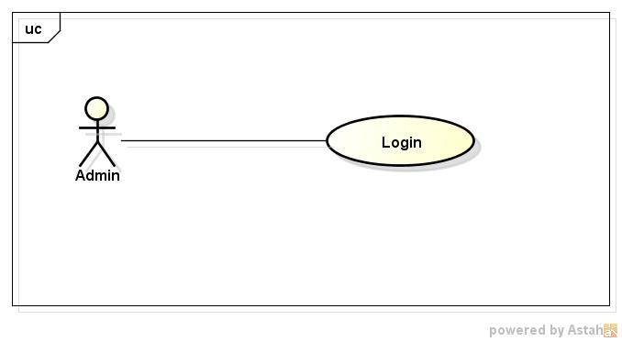
3.2.5. Login Admin

Figure 17 – Login Admin

The admin should have a special account that when recognized by the system, redirects to the admin pages.

3.2.6. Monitor Accounts
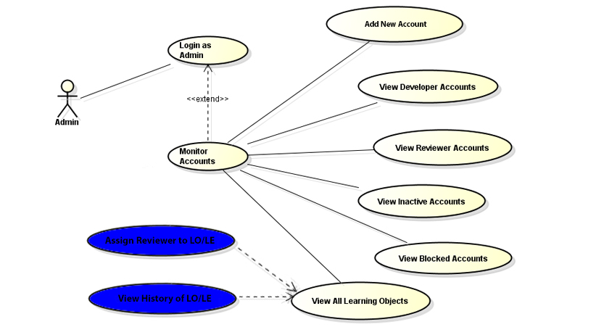
Figure 18 – Monitor Accounts
The admin can view all user account information. You can see all the developers and all the reviewers using the system. Before you can use our system, your account must first be confirmed by the admin.
Accounts will be considered to be inactive when there has been no activity for a year and will be candidates for blocking. The admin can also unblock the accounts that have been blocked. It is up to the admin to decide.
The admin can see all the learning objects LOOP has. He/she has no restrictions when it comes to viewing and downloading the learning objects. The admin is the only one who can give a rating of five (5) to a learning object.

3.2.7. Account Actions
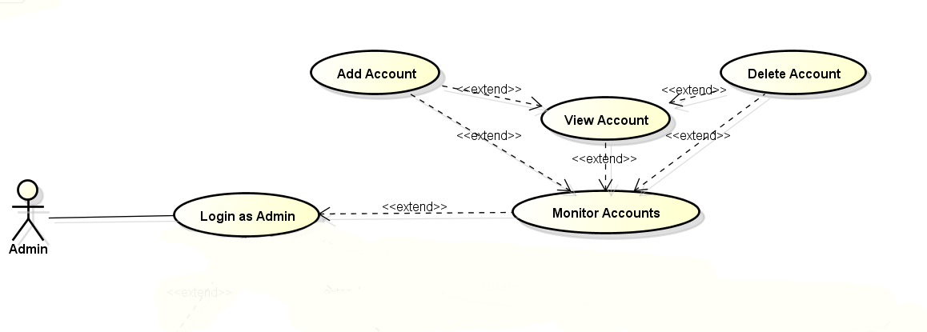
Figure 19– Account Actions

The admin should be able to view account information, block accounts and be able to unblock accounts as well.

3.2.8. Add New Account Requests
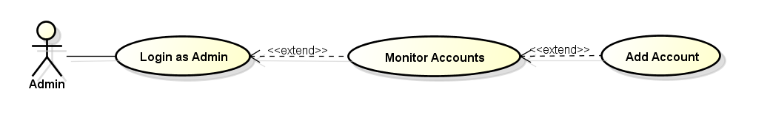
Figure 20– Accept New Account Requests
Only the admin can create an account before the developer or reviewer can use LOOP. This is a great way to filter the users of LOOP because only faculty members and authorized personnel will be able to use LOOP.

3.2.9. Search Account
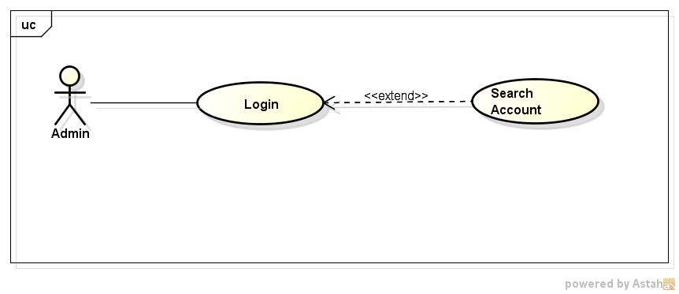

Figure 21 – Search Account
The admin can search a specific account by username using a search box above the account lists.

3.2.10. Change Password
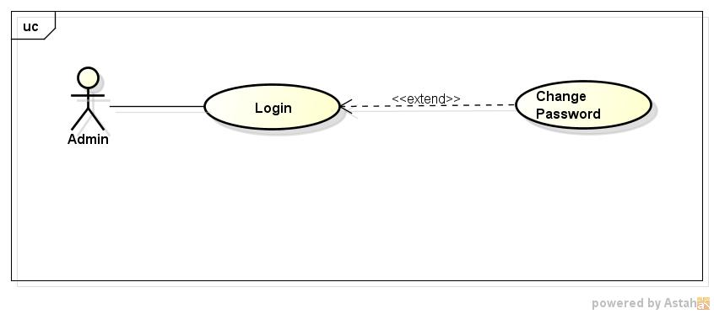

Figure 22 – Change Password
The admin should be able to change the password whenever it seems necessary.

3.2.11. Block User
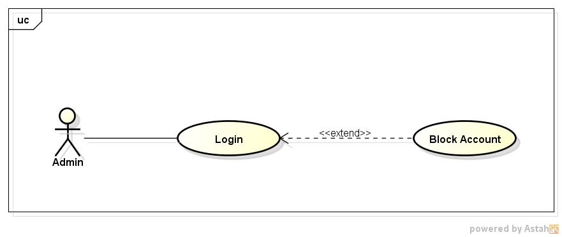
Figure 23 – Block User
The admin will have the authority to block users that are no longer active or have been reported for account blocking. Clicking any registered account will display a pop-out message that will prompt the admin if the account is to be blocked.

3.2.12. Delete Learning Objects
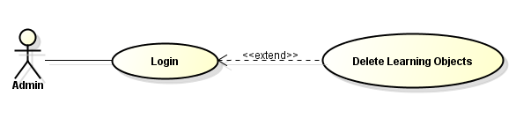
Figure 24 – Delete Learning Objects

The admin can delete a learning object that he/she chooses to for valid reasons. The developer can only delete learning objects that he/she has uploaded but the admin has the right to delete any learning object.

3.2.13. Review Learning Objects
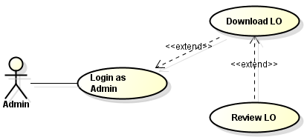
Figure 25 – Download and Review Learning Objects
The admin can review learning objects only if they have successfully downloaded the learning objects. If the download was unsuccessful, then the admin must wait until a successful download in order to review a learning object.

Performance Requirements
There should be minimal processing load in the system to allow for efficient transfer of files between the client and server. The goal is to accomplish an upload time of not more than 15 minutes depending on the file size of the learning object. Page response times should be less than 5 seconds if not instant, given that the network is not congested.
The system should be smooth and easy to use in both desktop and mobile devices. We have designed this site to be responsive, so it will be viewable on all devices especially on mobile devices.

3.4. Design constraints
- Learning object files taken from this system are only guaranteed to be playable on the Learning Object Players that are being developed in parallel with this system. The players come in iOS, android and windows desktop versions. Consequently, the learning objects might only be playable on these platforms.
- File orientation of the source files must be kept universal for all related systems that handle the learning objects. One of the greatest challenges of this project would be finding a generic file orientation that is playable and viewable for all systems concerned.

3.5. Software system attributes
Reliability: The system should provide accurate and up to date learning objects to avoid dissemination of wrong information. This is why the system must filter the categories of the learning objects accurately.
Accessibility: The system should be accessible anywhere within the range of the CIT-U eLearning Server.
Security: The system should not have any loopholes in security, such as direct links to restricted pages/resources.
Maintainability: The system should be developed in a framework that is easily maintainable. Code should be well organized and each development stage should be documented and presented to the client in due time.
Portability: The system must be compatible to all related platforms (Windows desktop, Mac, iOS and Android).

3.6. Other requirements
Other than simply providing learning objects to the users, our system must contribute to make the uploaded learning object viewable and reviewable to the expected users. This is for the future evolution of the system wherein users can be charged for each learning object they will be able to download, but this can only be realized when our filtering system will be flawless. Our job is to get all the learning objects ready for use by allowing extensive reviews and revisions to give you the best learning objects possible.

Appendixes

These are our references for the UI design of LOOP or Learning Object Organizer Plus.
Note: These are not part of the SRS and therefore are not requirements for this system.
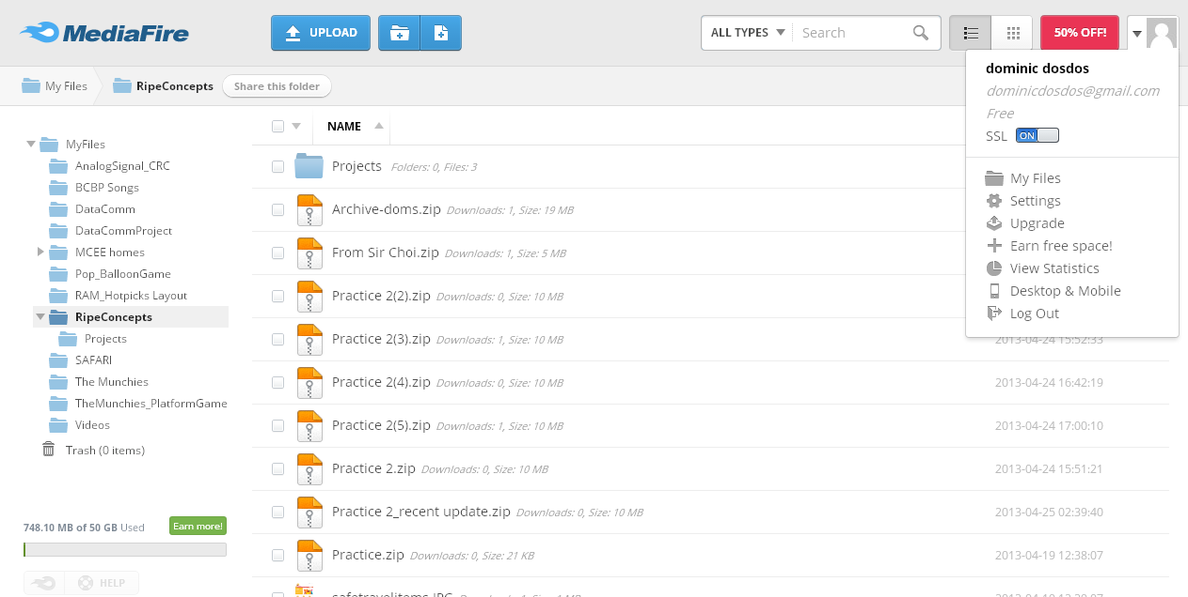
MediaFire - Upload an unlimited number of files to share with friends and family or storage. Use folders to easily share groups of files or create galleries for all your images. No registration necessary and no software to install. Keep frequently used files online for easy access from any computer with an internet connection.

Figure 26
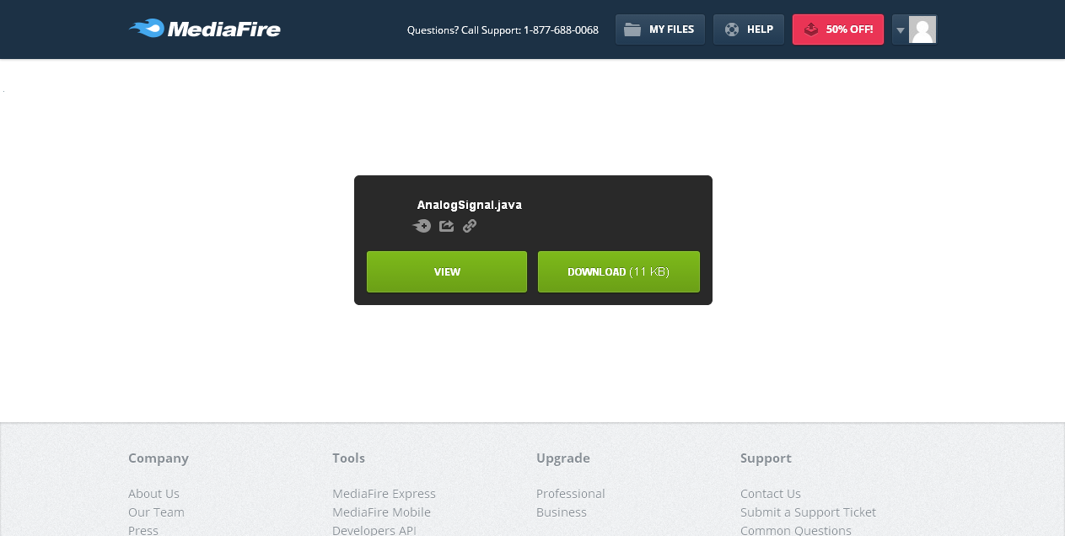

Figure 27
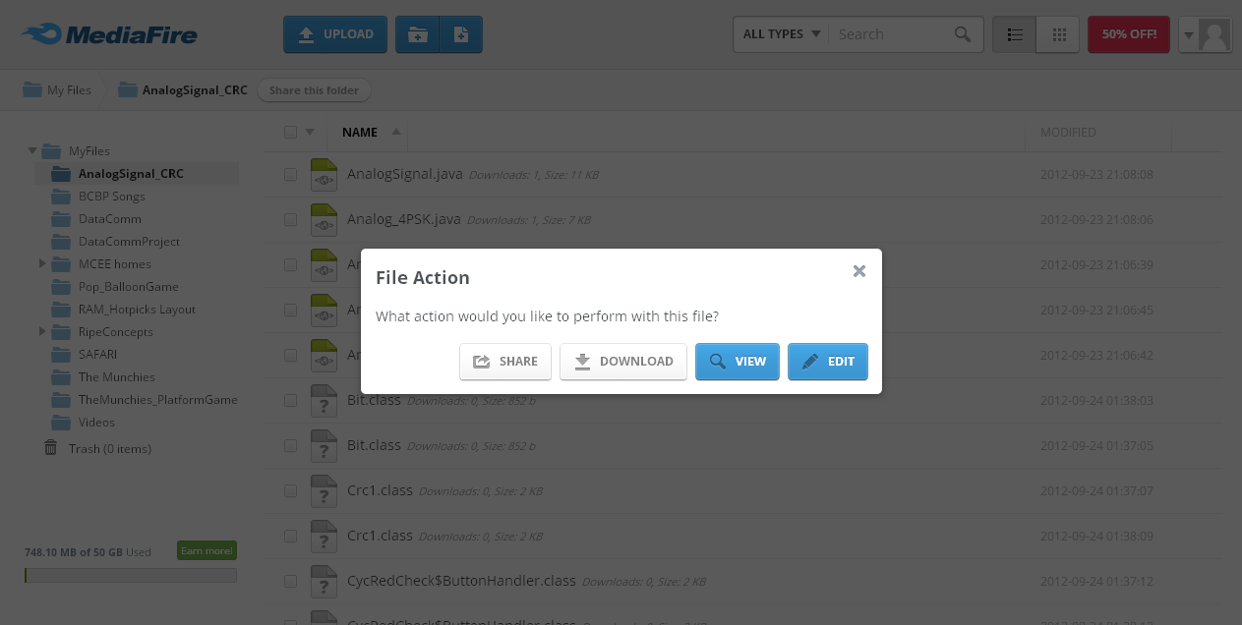

Figure 28

Relay - is an AJAX-enabled and PHP based file manager with a fairly intuitive interface for uploading, managing and downloading files. The application is pretty responsive and dynamically loads your folders and files. If you’re already storing your files in a particular folder on your FTP server, you can configure Relay to manage files at that location.
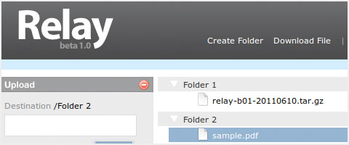

Figure 29

Index

